**PROJECT TITLE: Medical Inventory Management**

**College Name: Kamalam College of Arts and Science**

**College Code:bru5s**

**TEAM ID:** **NM2025TMID26785**

**TEAM MEMBERS:** 5

**Team Leader Name:** **VENKADESH S**

**Email: venkatsubramaniamhelp@gmail.com**

**Team Member: ABILA T**

**Email: abila22005@gmail.com**

**Team Member: AKSHAYAKUMAR P T**

**Email: akshay160505@gmail.com**

**Team Member: LOGESHWARI M**

**Email: losini867@gmail.com**

**Team Member:  NAVEEN A**

**Email: naveennaveen9884@gmail.com**

**INTRODUCTION**

**Project Overview**

**Medical Inventory Management project built on Sales force**. This type of project typically helps healthcare organizations manage medical supplies, equipment, and pharmaceuticals efficiently, ensuring compliance, real-time tracking, and optimized inventory levels.

To develop a centralized, cloud-based Medical Inventory Management System using **Sales force** to track, manage, and optimize the procurement, usage, and stock levels of medical supplies across hospitals or clinics.

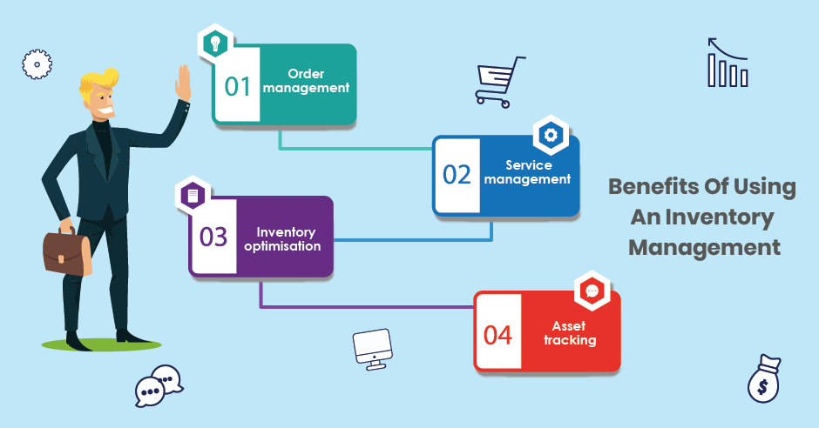

**Purpose**

**The primary purpose of the Medical Inventory Management System built on Sales force is to:**

**Enable healthcare organizations to efficiently manage, track, and optimize medical supplies and equipment in real-time, ensuring operational continuity, compliance, and better patient care.**

**DEVELOPMENT PHASE**

Creating Developer Account:[**https://developer.salesforce.com/signup**](https://developer.salesforce.com/signup)

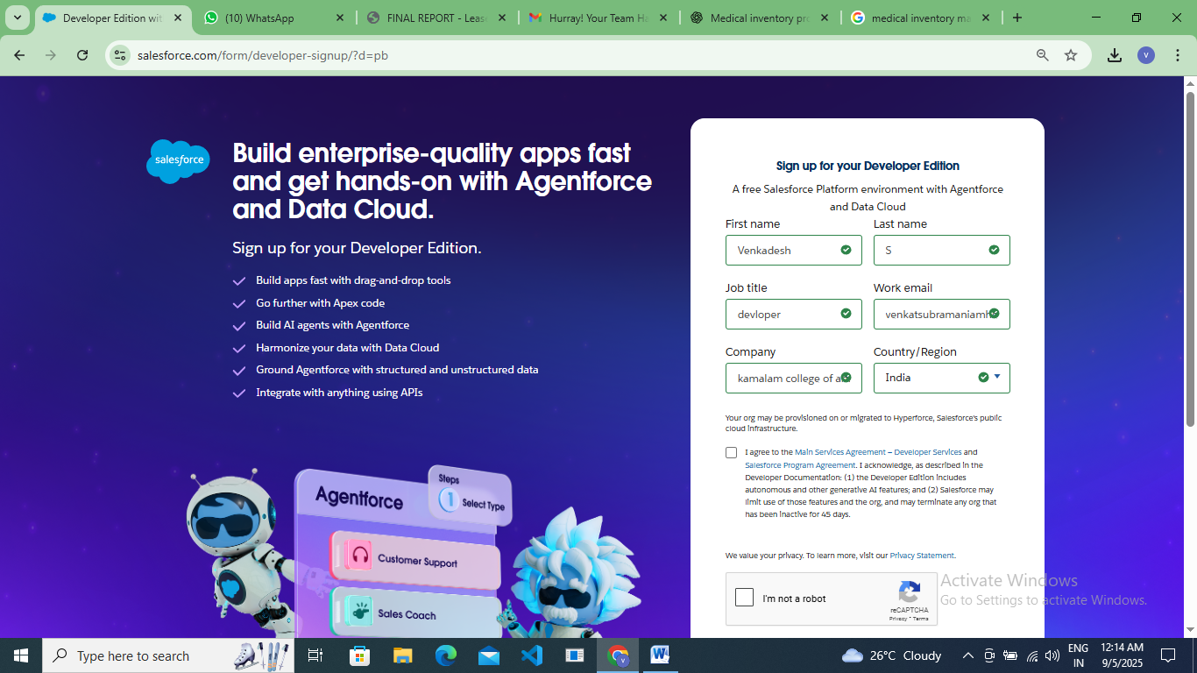

**Account Activation**

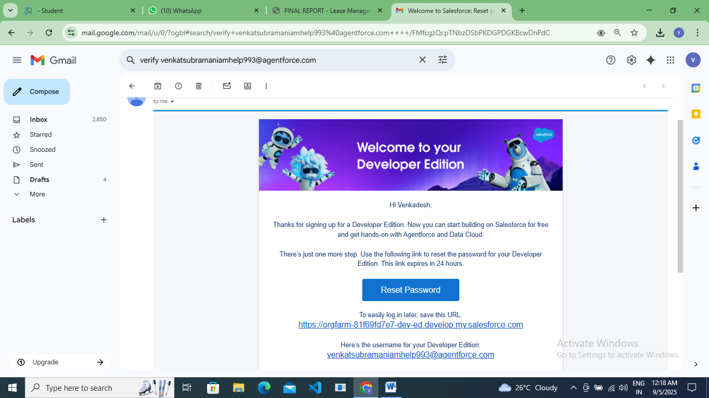

### Creating a Product Object

Created objects: Product, Purchase Order, Order Item, Inventory Transaction and Supplier objects.

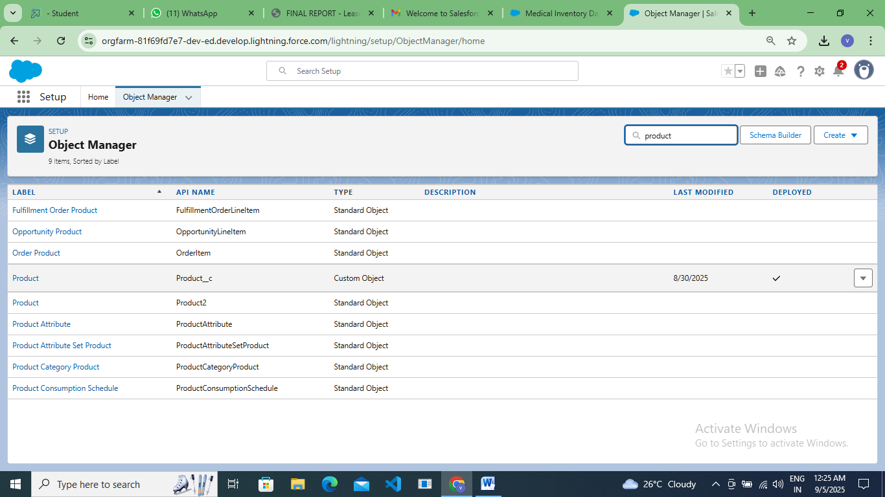

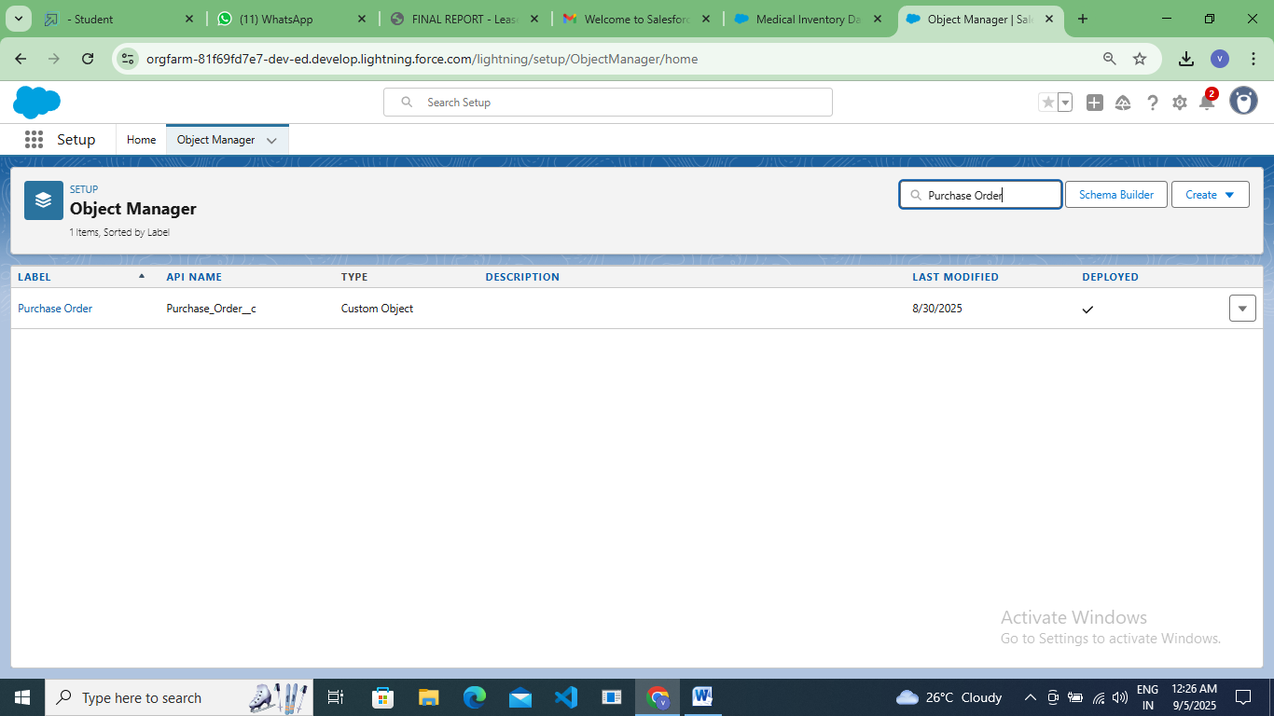

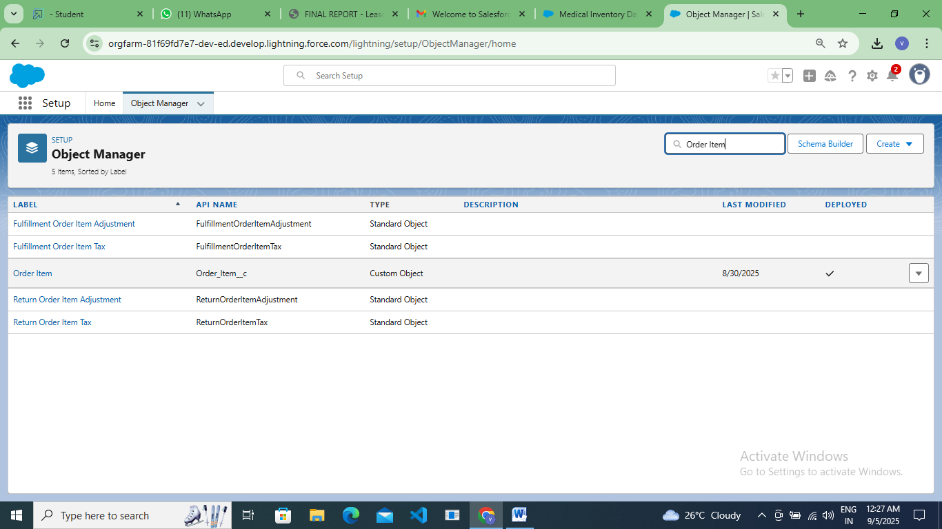

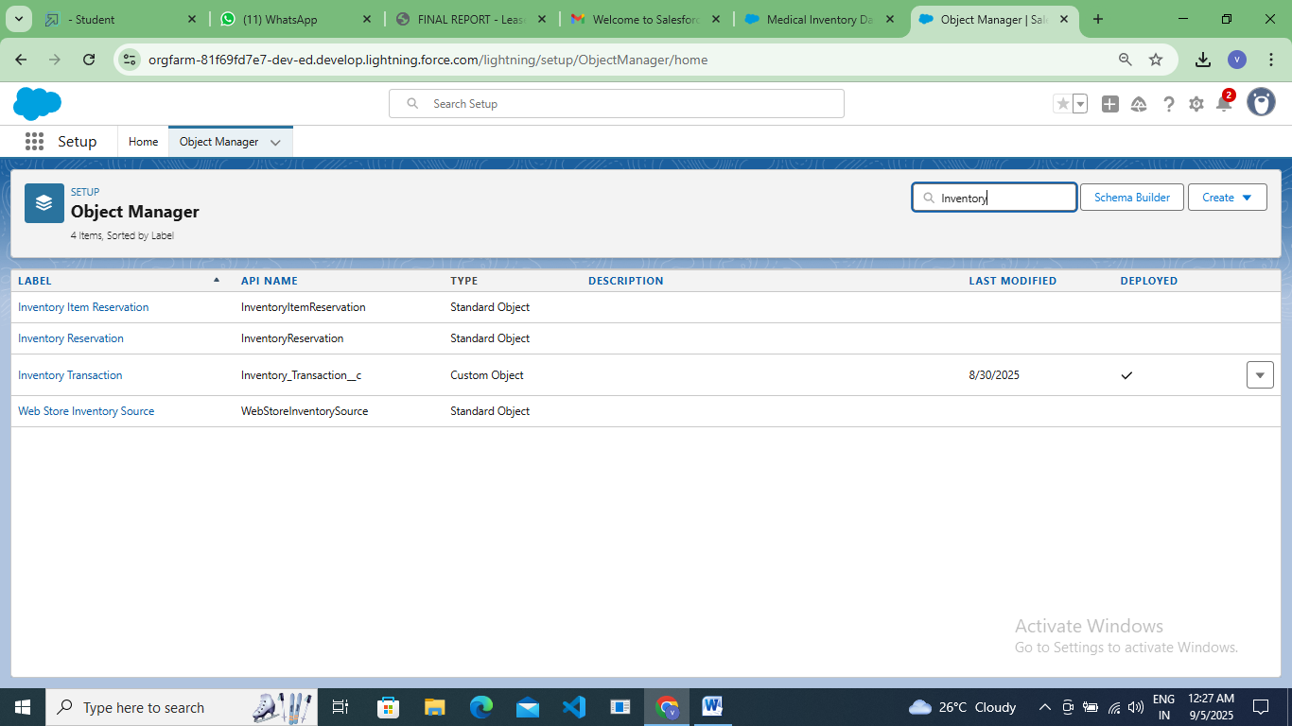

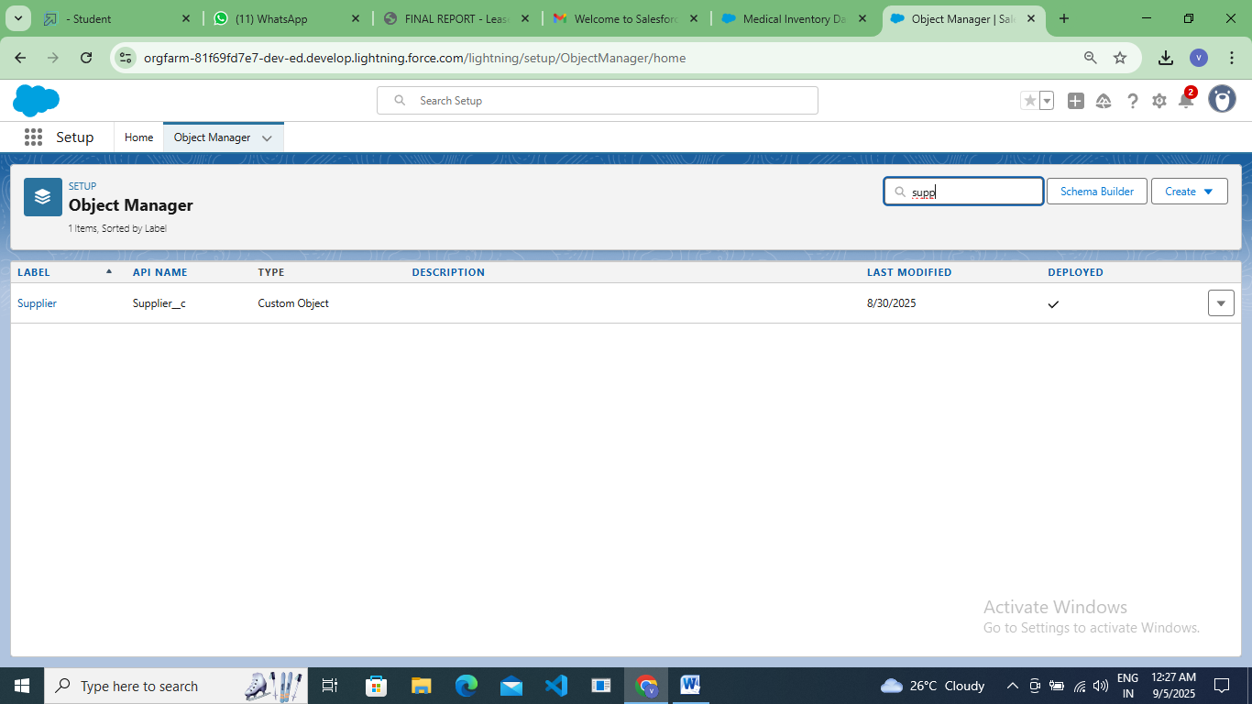

### Tabs

### Created Tabs: Product, Purchase Order, Order Item, Inventory Transaction and Supplier .

### 

**Developed Lightning App**

### Create a Lightning App for Medical Inventory Management

### 

### 

### 

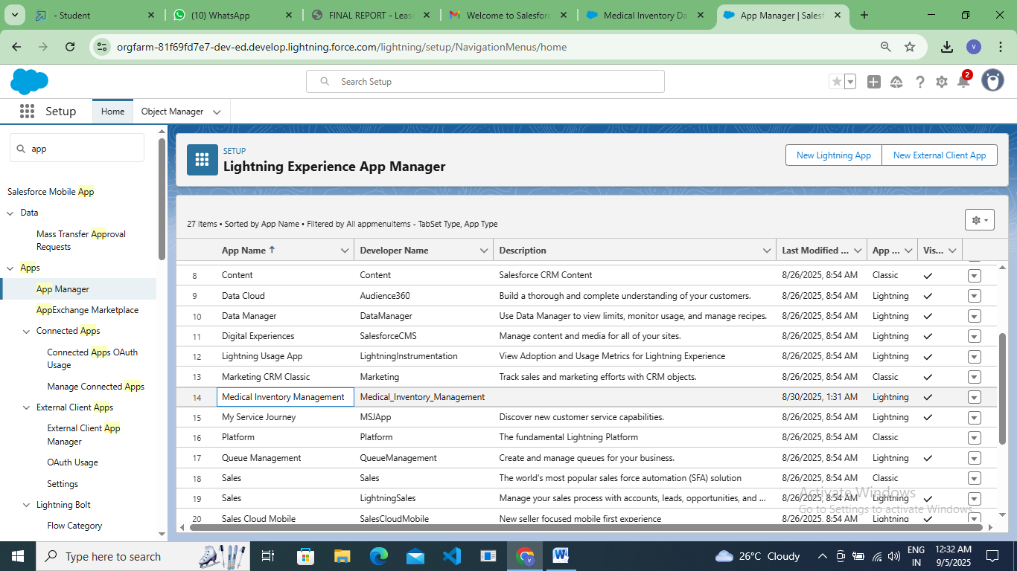

### Fields

**Product**

Created Product ID , Product Name , Product Description , Minimum Stock Level , Current Stock Level , Unit Price , Expiry Date in Product object Fields and Relationships.

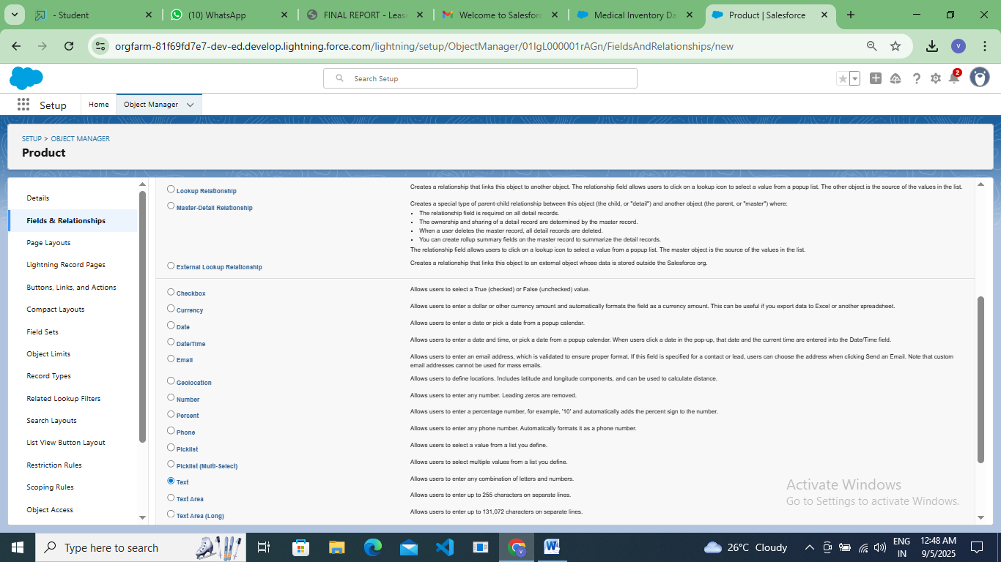

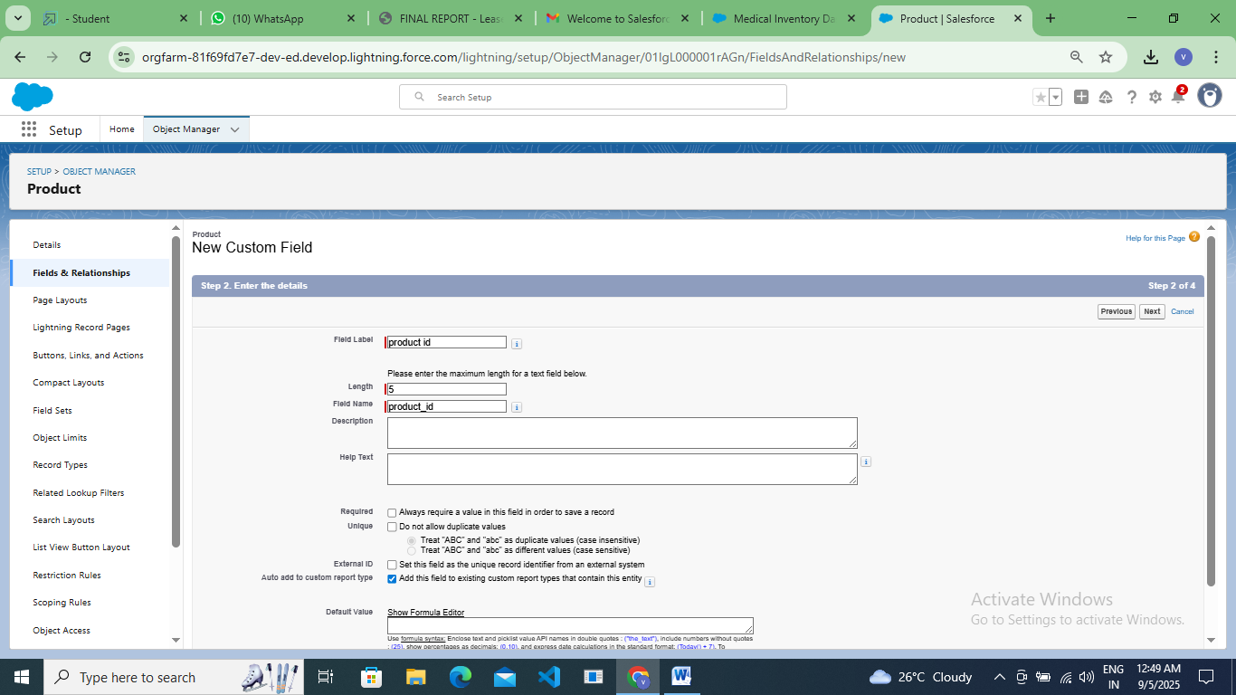 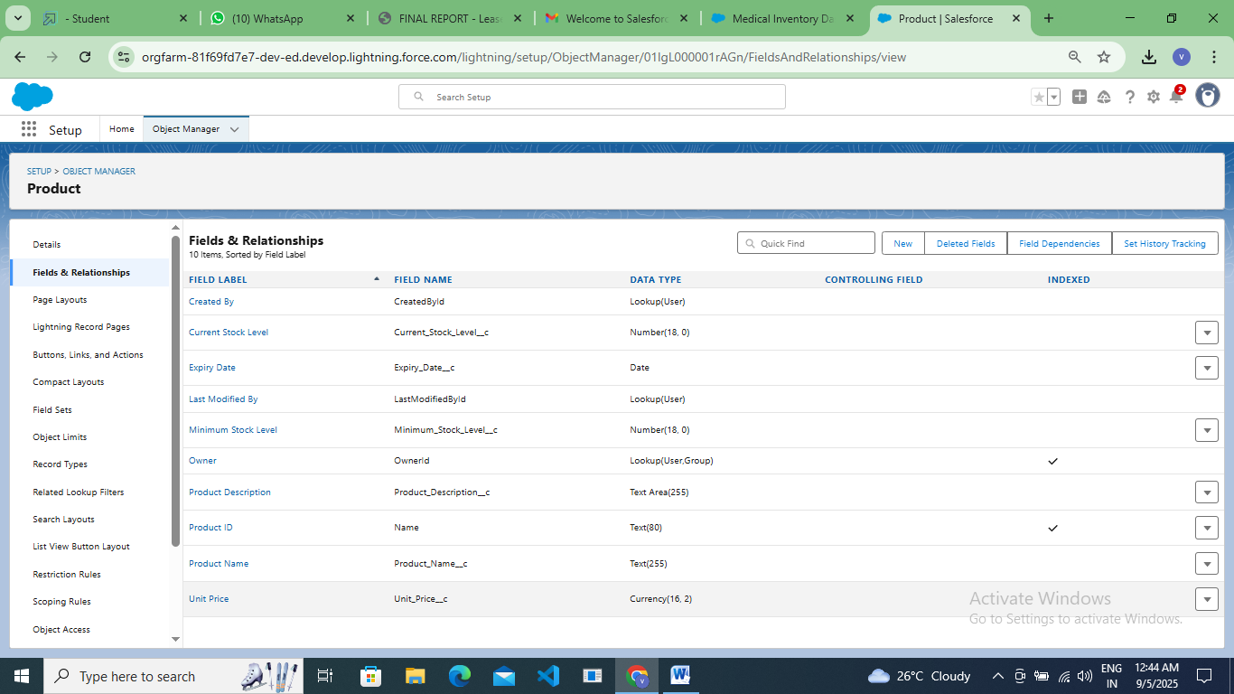

**Purchase Order**

Created Purchase Order ID, Supplier ID Lookup(Supplier), Order Date, Expected Delivery Date, Actual Delivery Date, Order Count, Total Order Cost

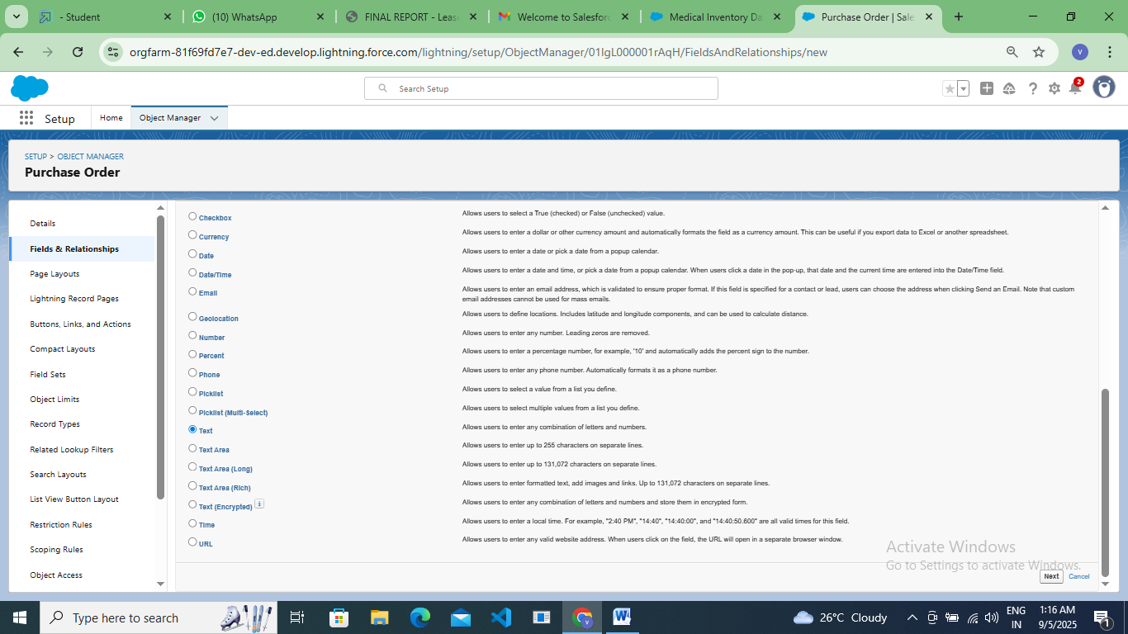

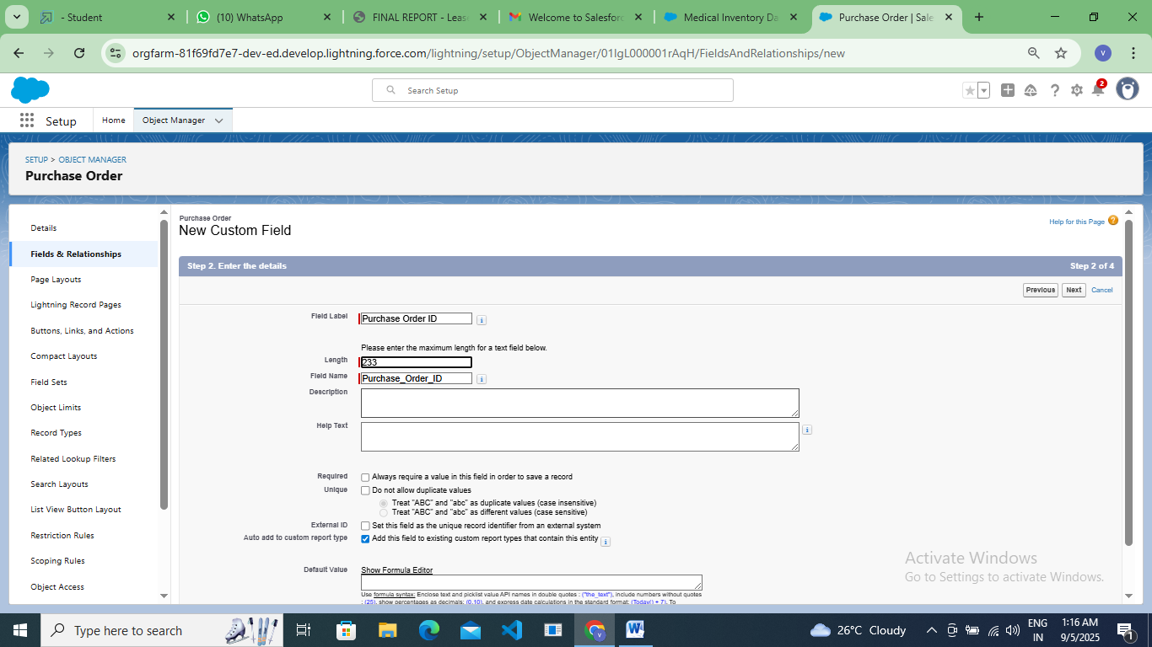

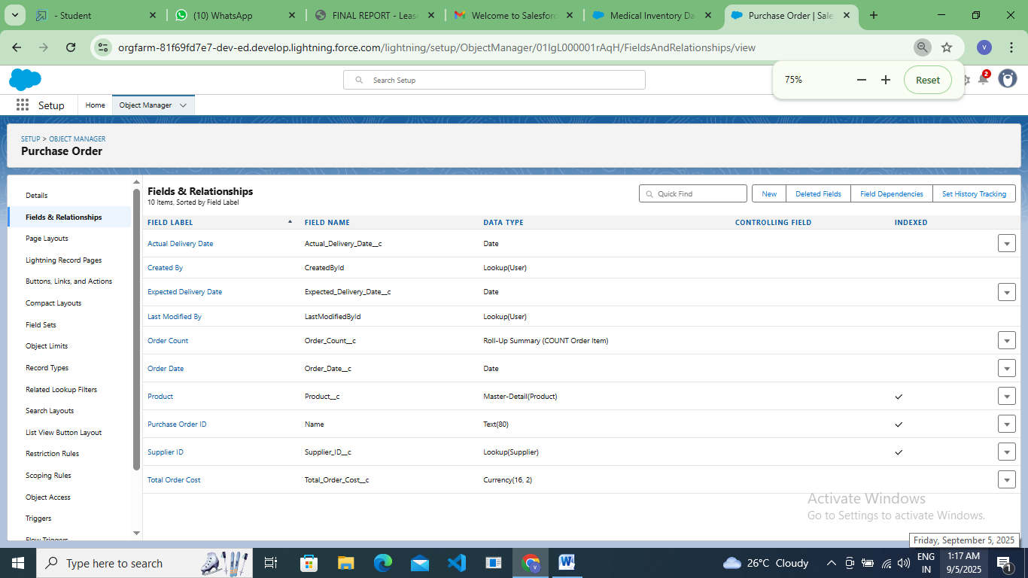

**Order Item**

Created Order Item ID, Product ID Lookup(Product), Purchase Order ID, Quantity Ordered, Quantity Received, Unit Price & Amount using formula data type.

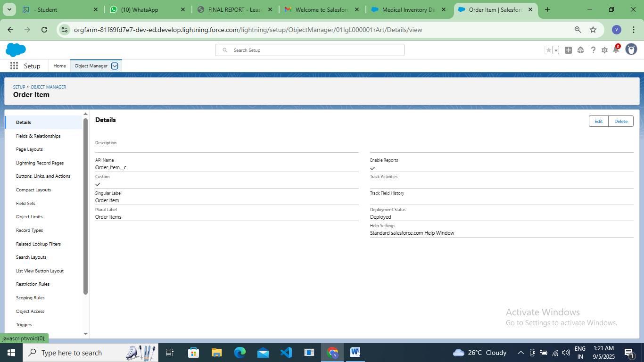

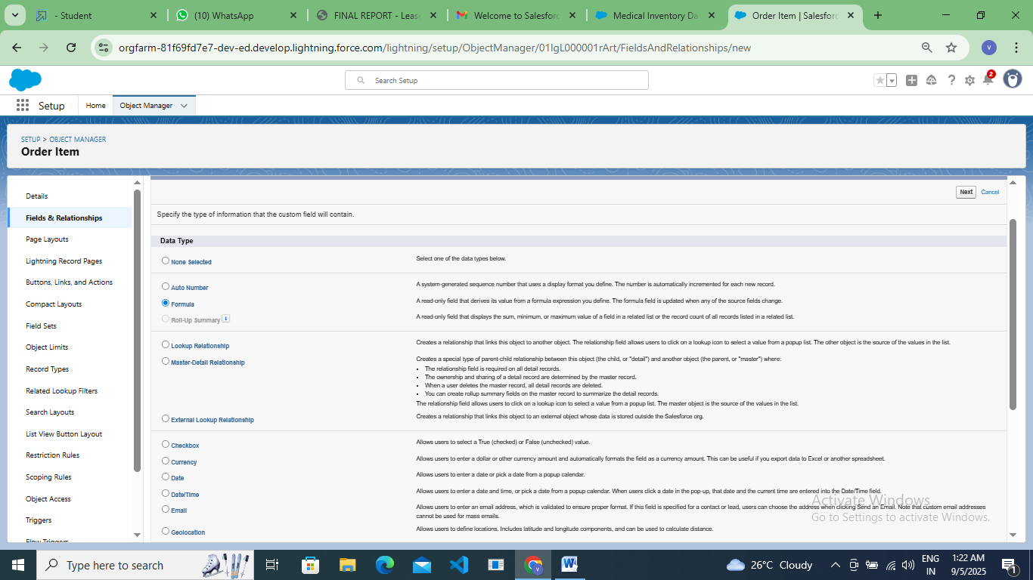

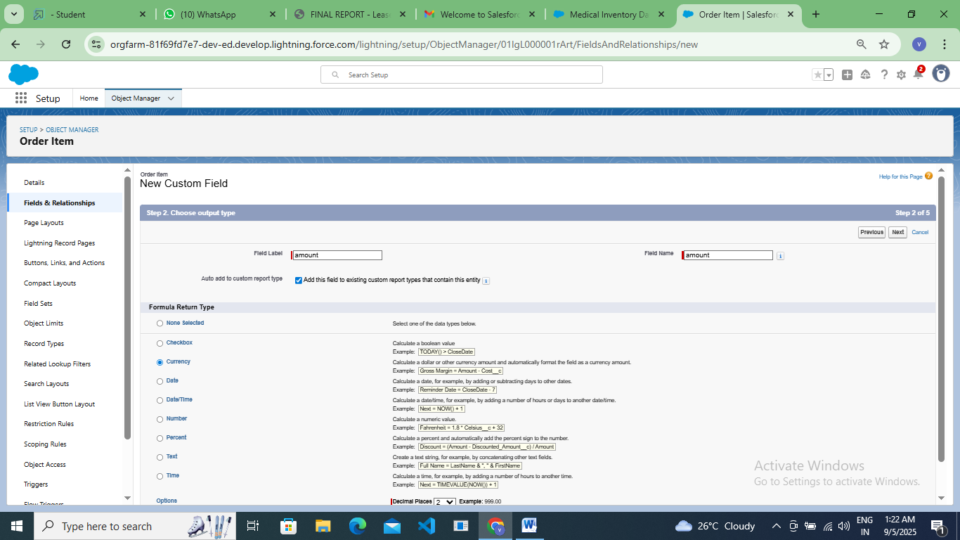

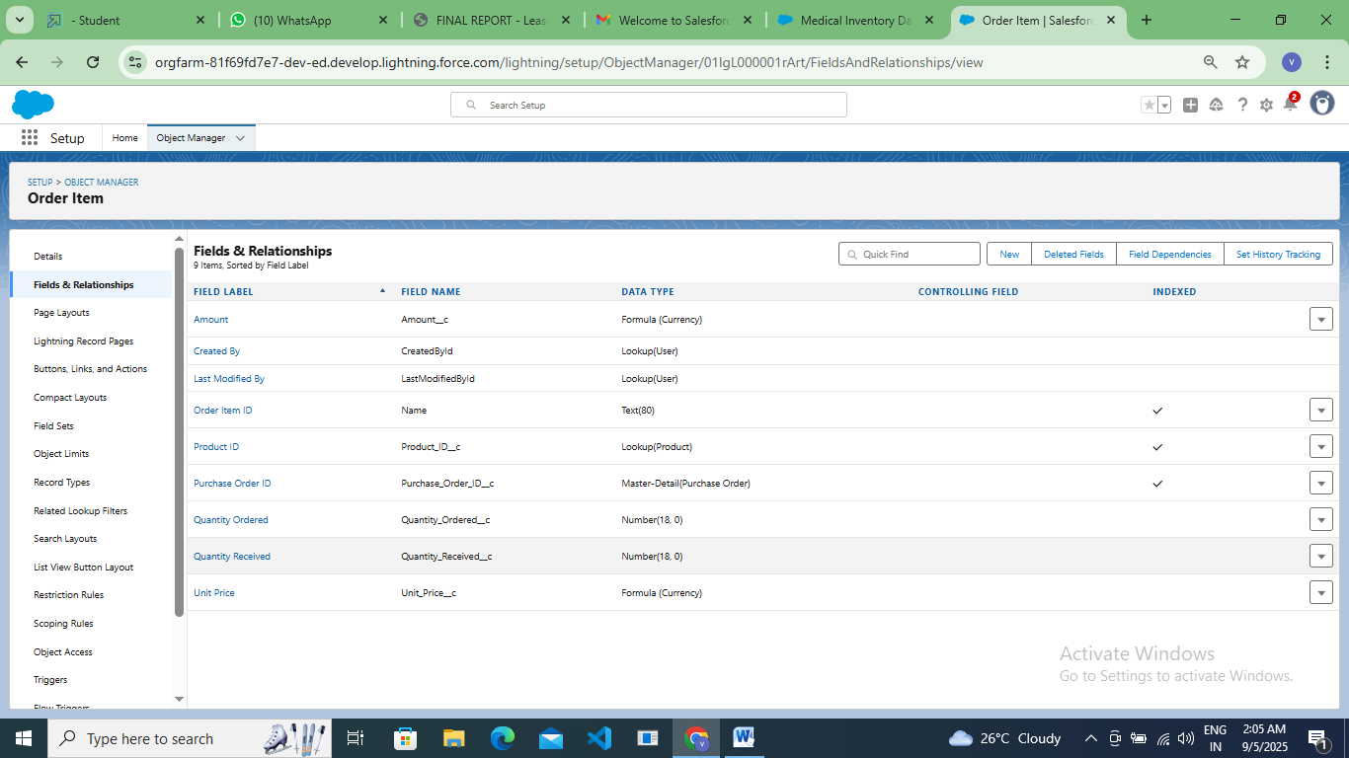

**Inventory Transaction**

Created Transaction ID, Purchase Order ID by using lookup type, Transaction Date, Transaction Type, Total Order Cost by using formula data type.

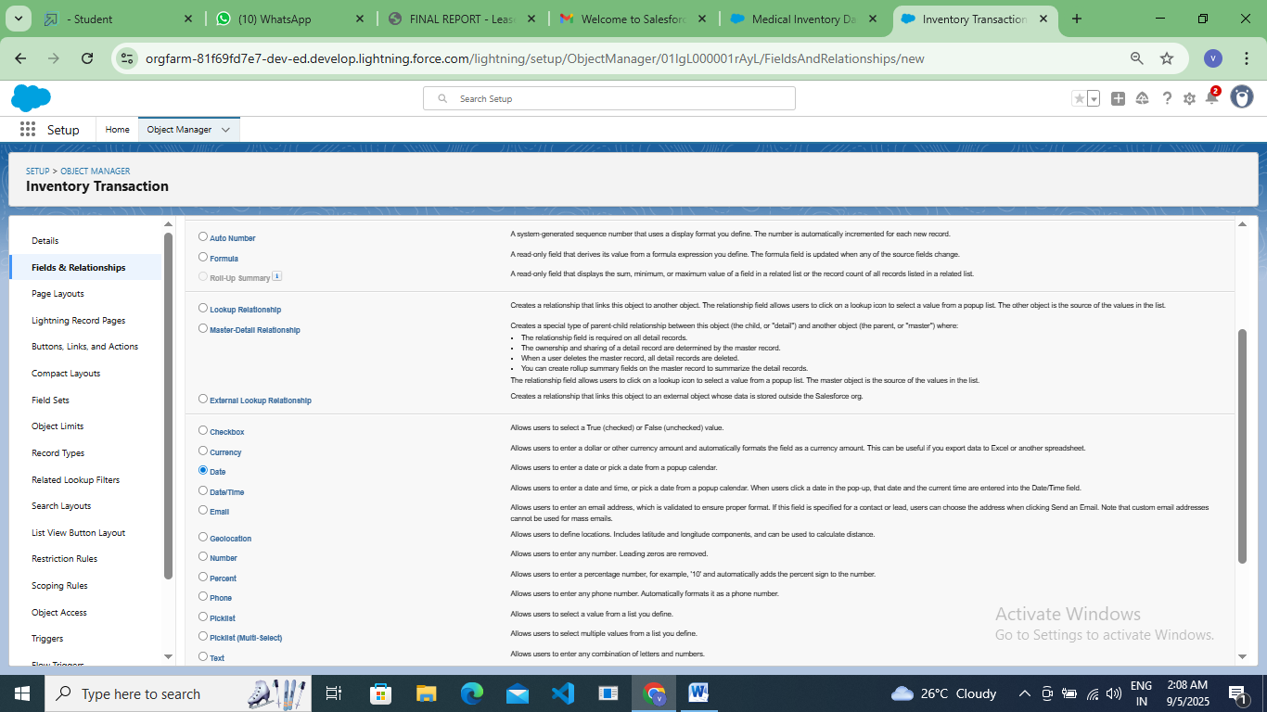

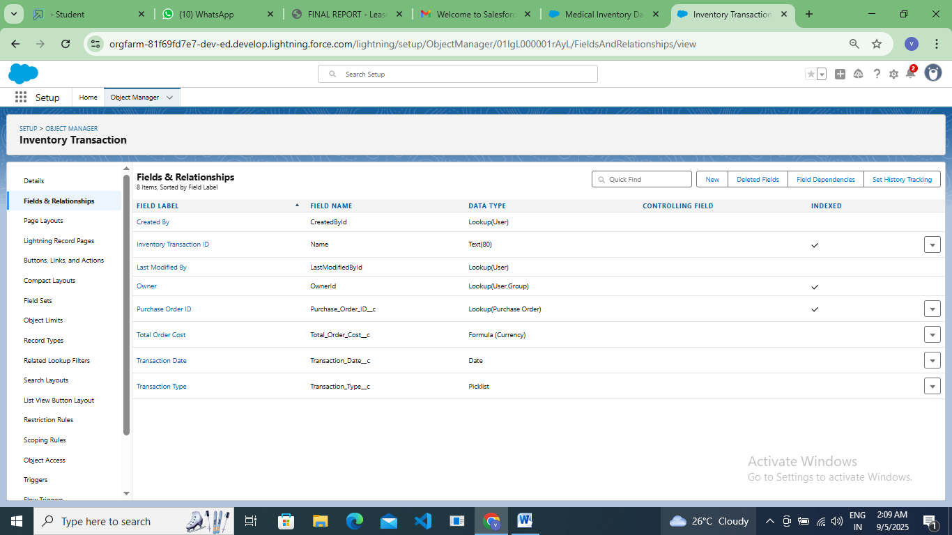

**Supplier**

Created Supplier ID, Supplier Name, Contact Person, Phone Number, Email, Address.

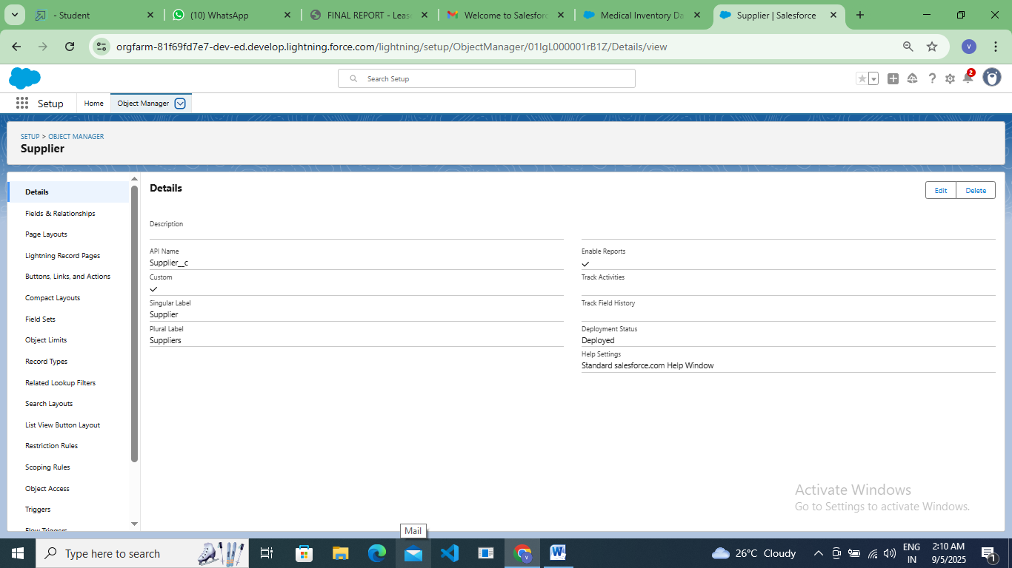

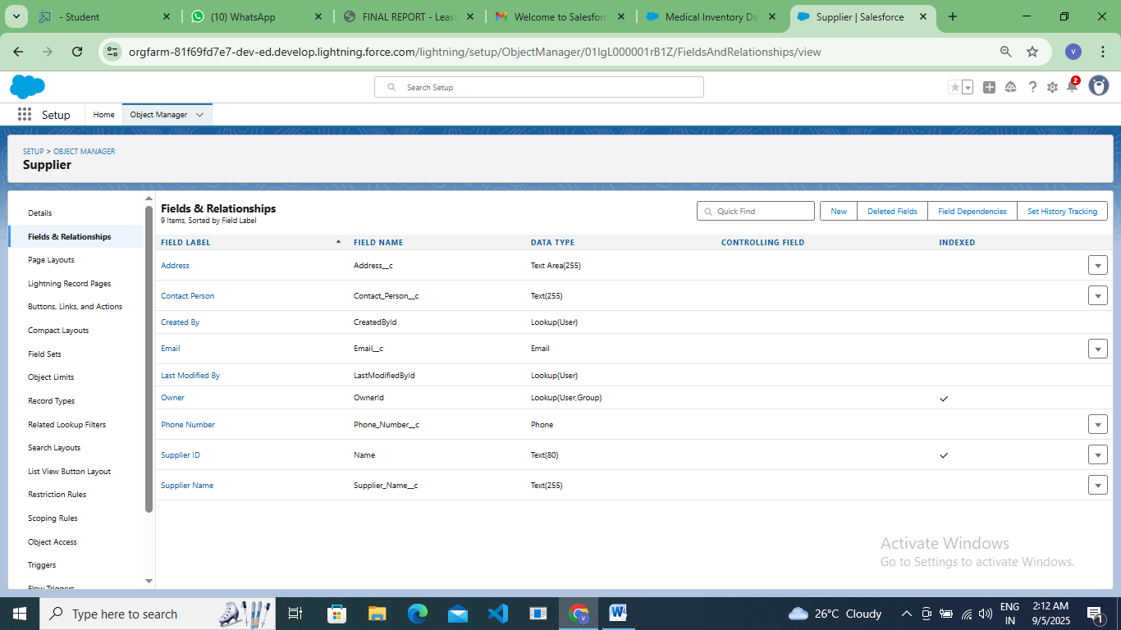

### Editing of Page Layouts

### To edit a Page Layout in Product Object:

### 

### 

### To edit a Page Layout in Purchase Order Object:

### 

### 

### To edit a Page Layout in Order Item Object:

### 

### 

### To edit a Page Layout in Inventory Transaction Object:

### 

### 

### 

### To edit a Page Layout in Supplier Object:

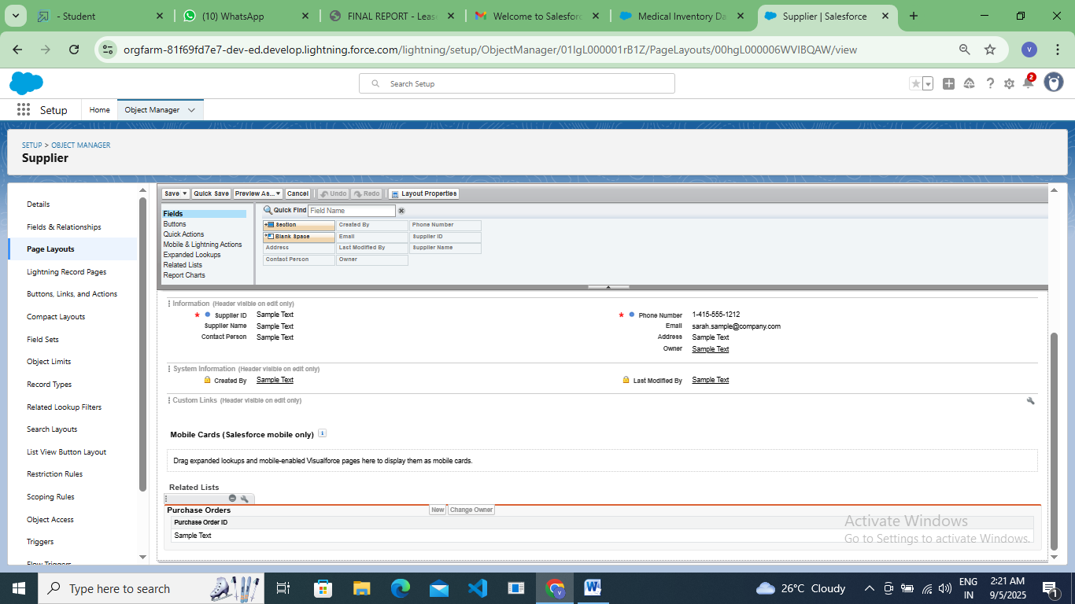

### Compact Layout

### Product

### 

### 

**Purchase order**

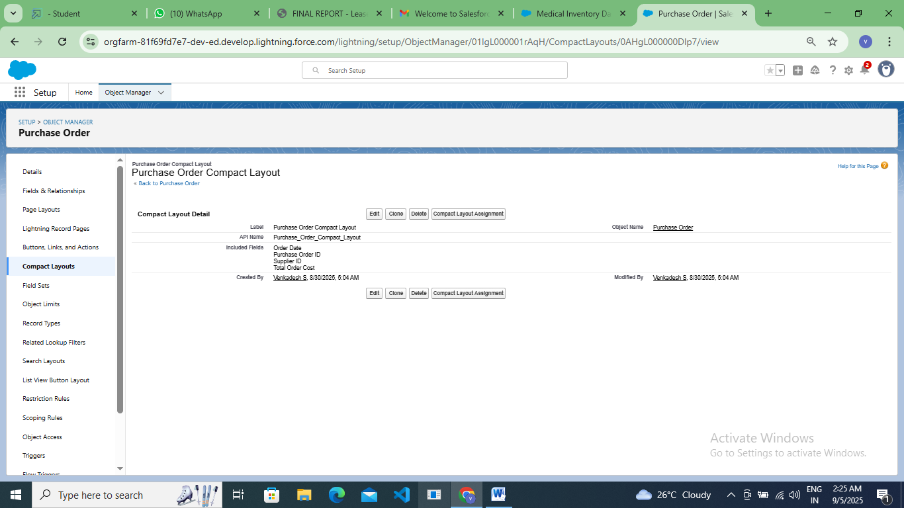

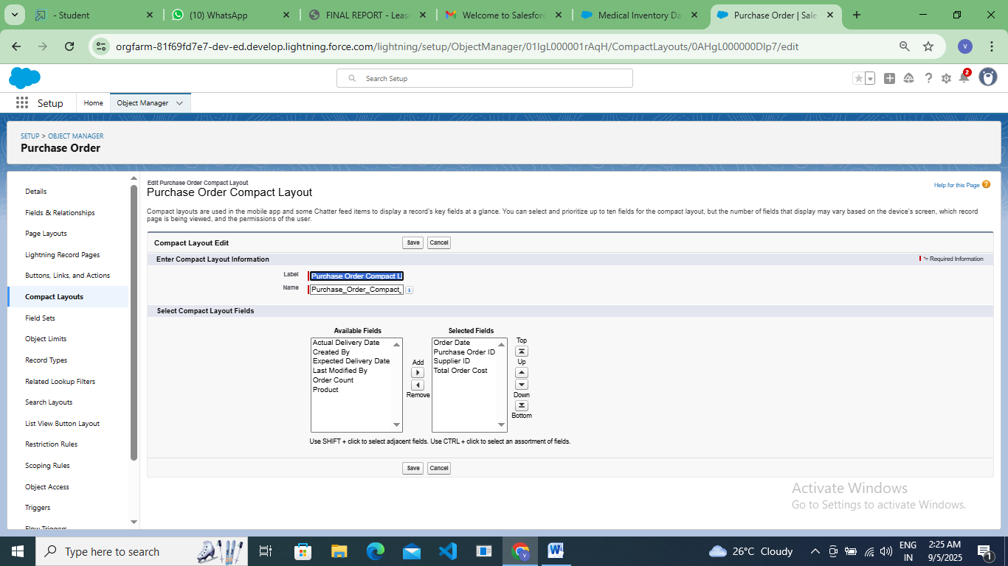

### Validation Rules

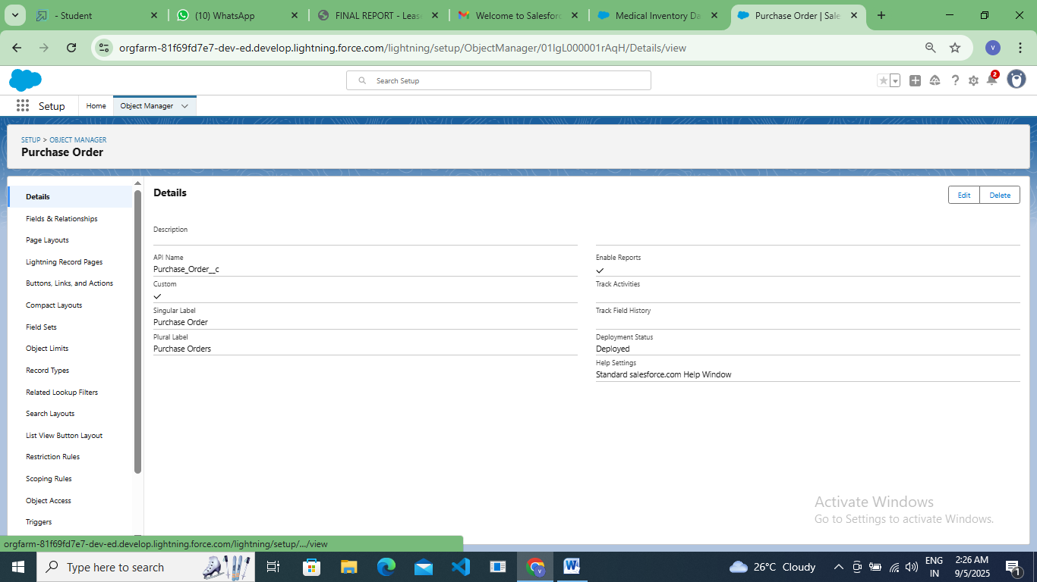

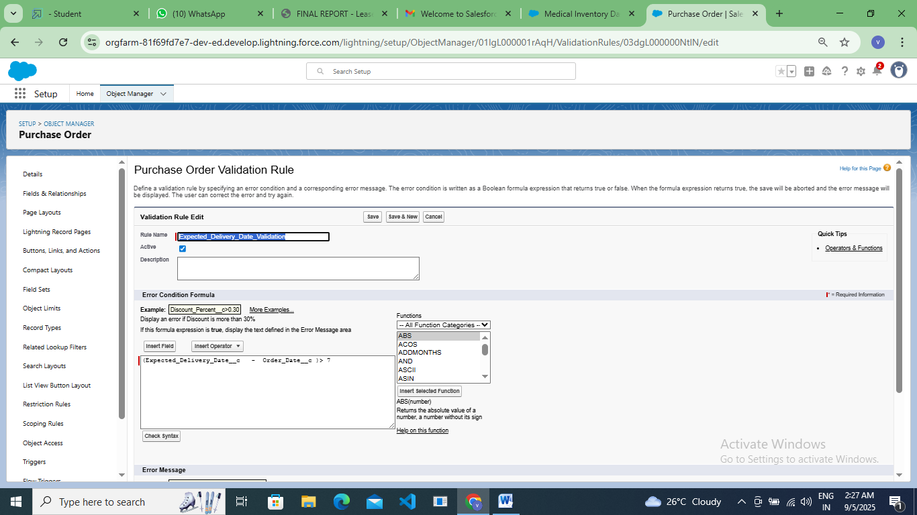

### Profiles

### To create an Inventory Manager Profile

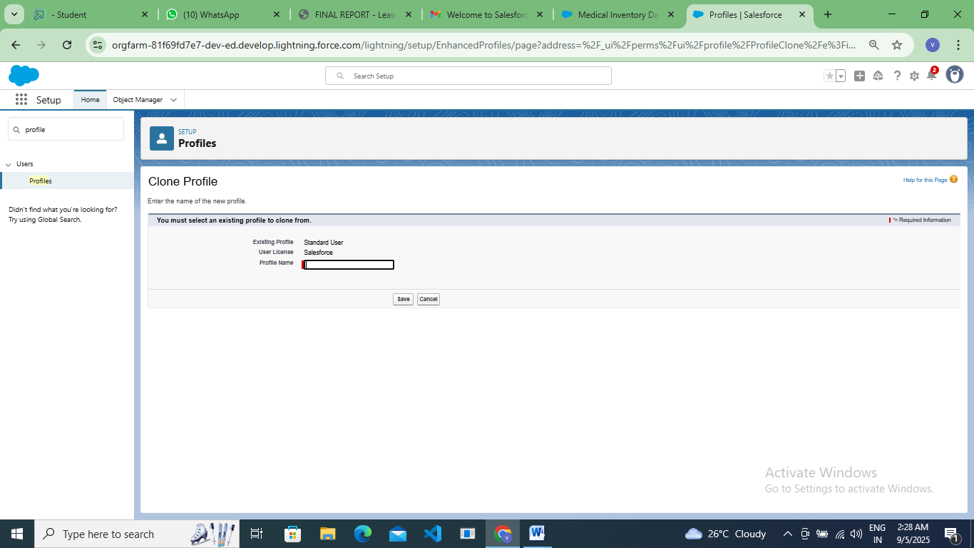

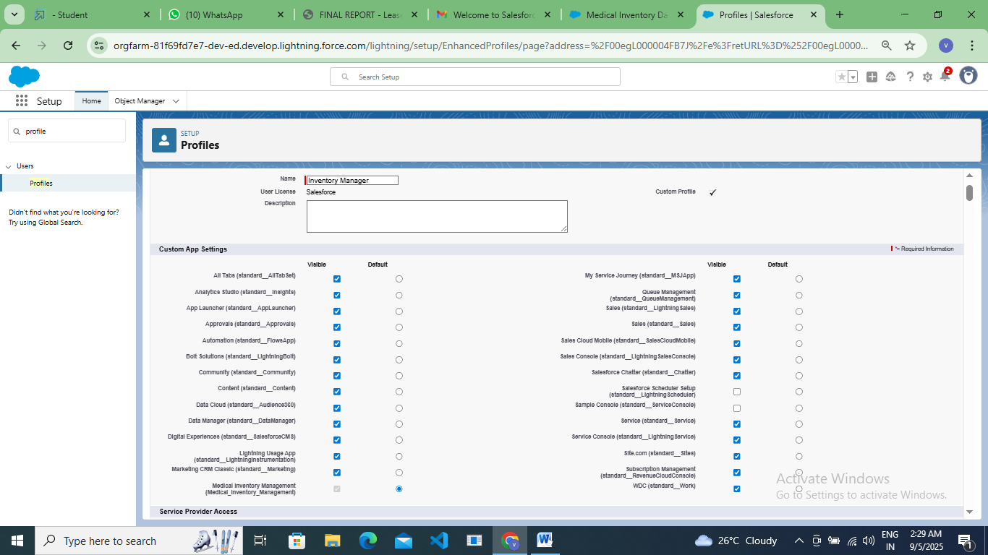

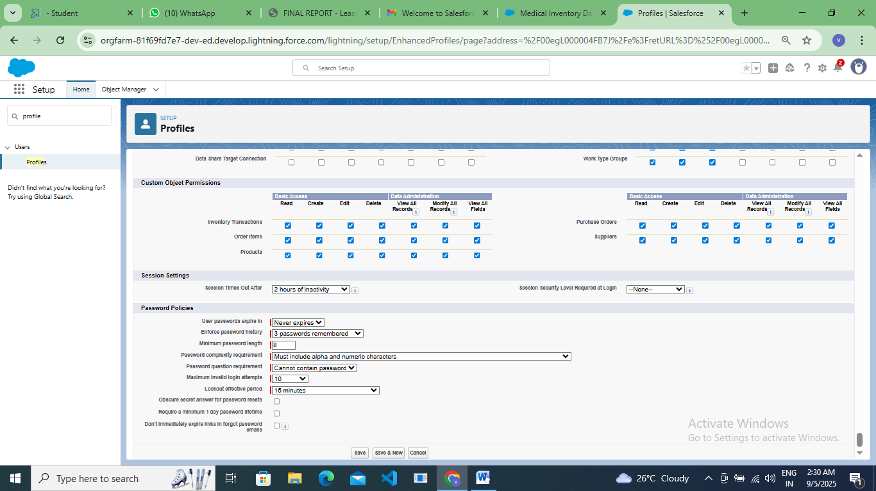

### To create an Purchase Manager Profile

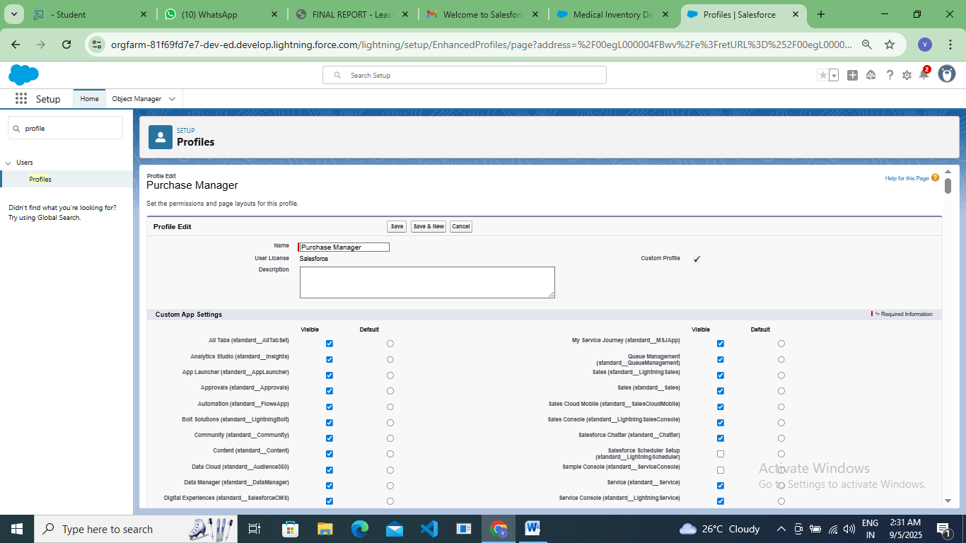

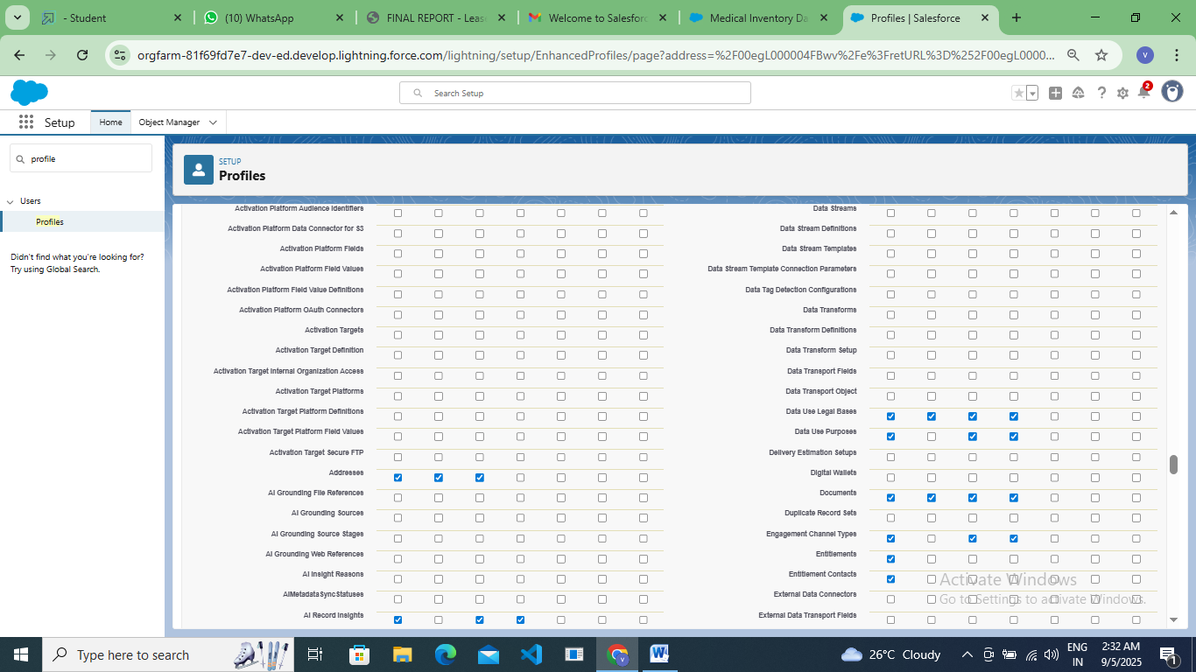

### Roles

### Create a Purchasing Manager Role

### 

### 

**Permission Sets**

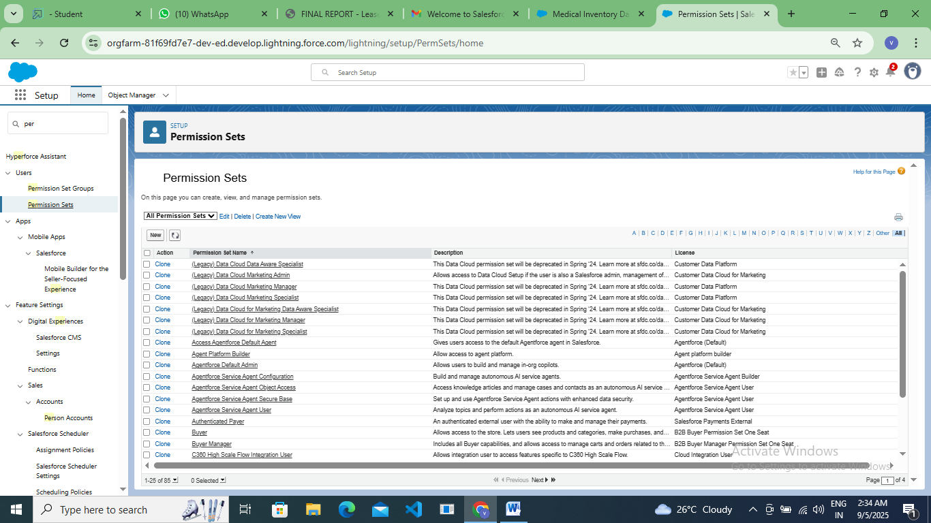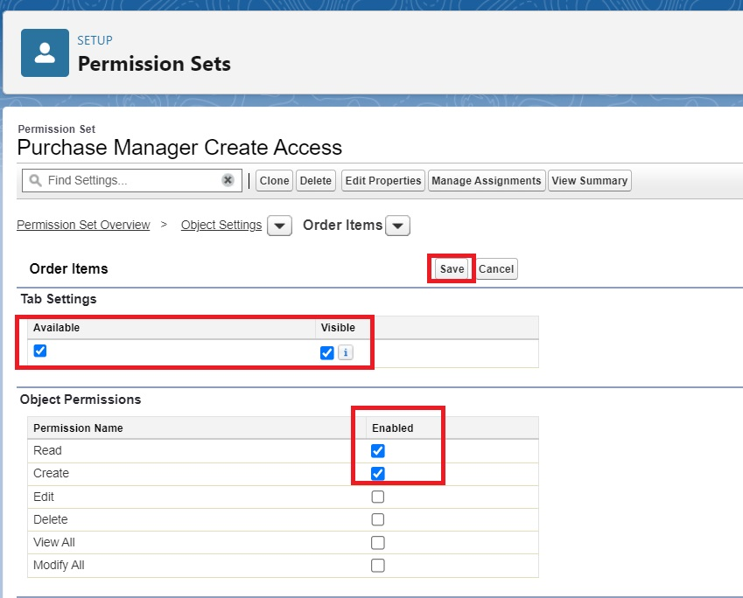

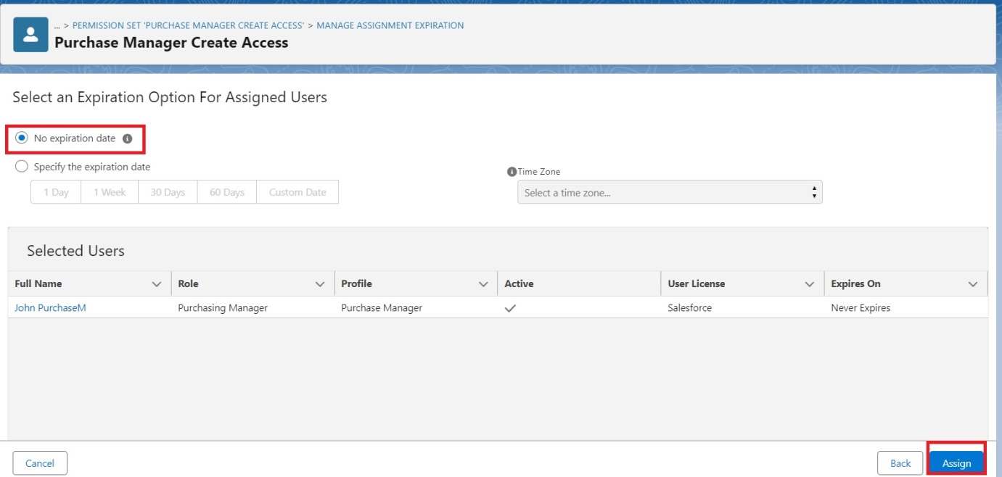

### Flows

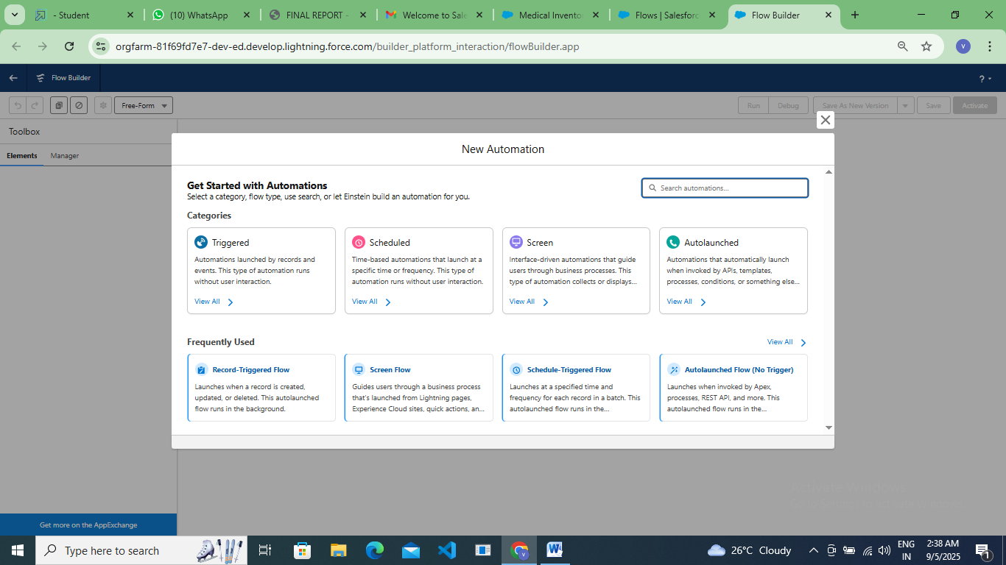

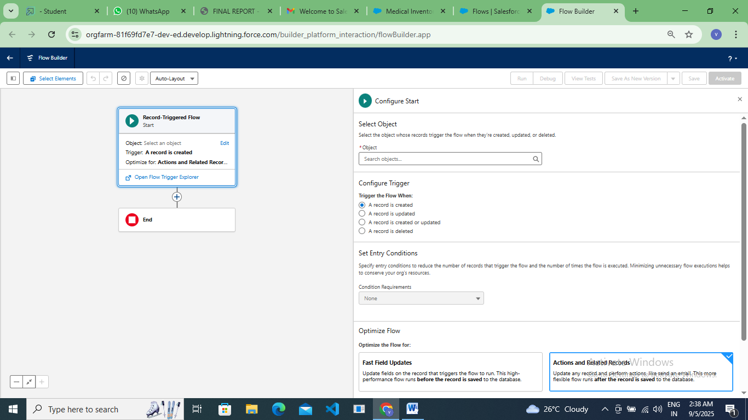

**Triggers**

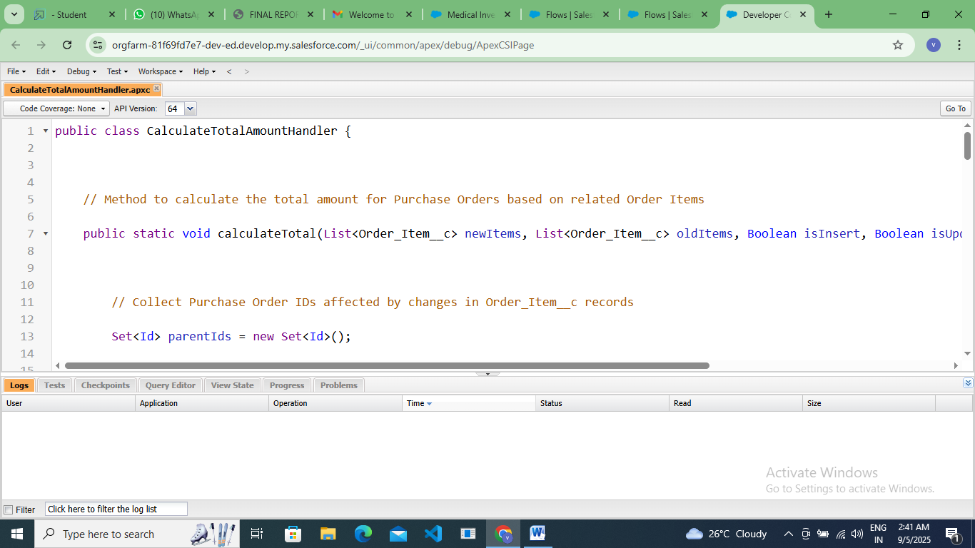

**APPENDIX ● Source Code: Provided in Apex Classes and Triggers:**

**CalculateTotalAmountTrigger:**

trigger CalculateTotalAmountTrigger on Order_Item__c (after insert, after update, after delete, after undelete) {

    // Call the handler class to handle the logic

    CalculateTotalAmountHandler.calculateTotal(Trigger.new, Trigger.old, Trigger.isInsert, Trigger.isUpdate, Trigger.isDelete, Trigger.isUndelete);

}

**CalculateTotalAmountHandler:**

 public class CalculateTotalAmountHandler {

    // Method to calculate the total amount for Purchase Orders based on related Order Items

    public static void calculateTotal(List<Order_Item__c> newItems, List<Order_Item__c> oldItems, Boolean isInsert, Boolean isUpdate, Boolean isDelete, Boolean isUndelete) {

        // Collect Purchase Order IDs affected by changes in Order_Item__c records

        Set<Id> parentIds = new Set<Id>();

        // For insert, update, and undelete scenarios

        if (isInsert || isUpdate || isUndelete) {

            for (Order_Item__c ordItem : newItems) {

                parentIds.add(ordItem.Purchase_Order_Id__c);

            }

        }

        // For update and delete scenarios

        if (isUpdate || isDelete) {

            for (Order_Item__c ordItem : oldItems) {

                parentIds.add(ordItem.Purchase_Order_Id__c);

            }

        }

        // Calculate the total amounts for affected Purchase Orders

        Map<Id, Decimal> purchaseToUpdateMap = new Map<Id, Decimal>();

        if (!parentIds.isEmpty()) {

            // Perform an aggregate query to sum the Amount__c for each Purchase Order

            List<AggregateResult> aggrList = [

                SELECT Purchase_Order_Id__c, SUM(Amount__c) totalAmount

                FROM Order_Item__c

                WHERE Purchase_Order_Id__c IN :parentIds

                GROUP BY Purchase_Order_Id__c

            ];

            // Map the result to Purchase Order IDs

            for (AggregateResult aggr : aggrList) {

                Id purchaseOrderId = (Id)aggr.get('Purchase_Order_Id__c');

                Decimal totalAmount = (Decimal)aggr.get('totalAmount');

                purchaseToUpdateMap.put(purchaseOrderId, totalAmount);

            }

            // Prepare Purchase Order records for update

            List<Purchase_Order__c> purchaseToUpdate = new List<Purchase_Order__c>();

            for (Id purchaseOrderId : purchaseToUpdateMap.keySet()) {

                Purchase_Order__c purchaseOrder = new Purchase_Order__c(Id = purchaseOrderId, Total_Order_cost__c = purchaseToUpdateMap.get(purchaseOrderId));

                purchaseToUpdate.add(purchaseOrder);

            }

            // Update Purchase Orders if there are any changes

            if (!purchaseToUpdate.isEmpty()) {

                update purchaseToUpdate;

            }

        }

    }

}

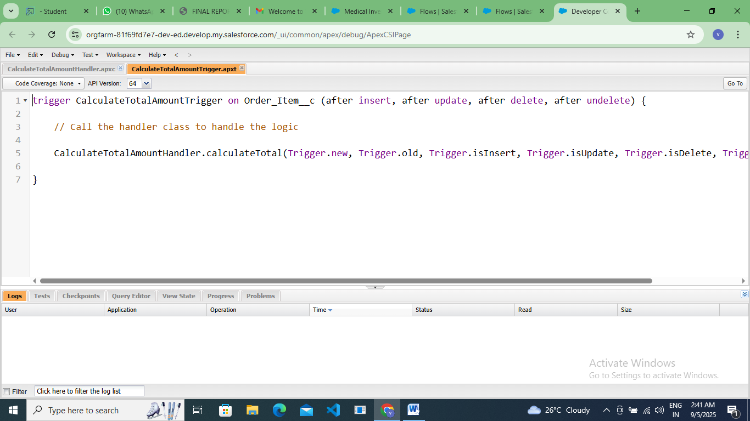

### Reports

### Purchase Orders based on Suppliers

### 

**Complete Purchase Details Report**

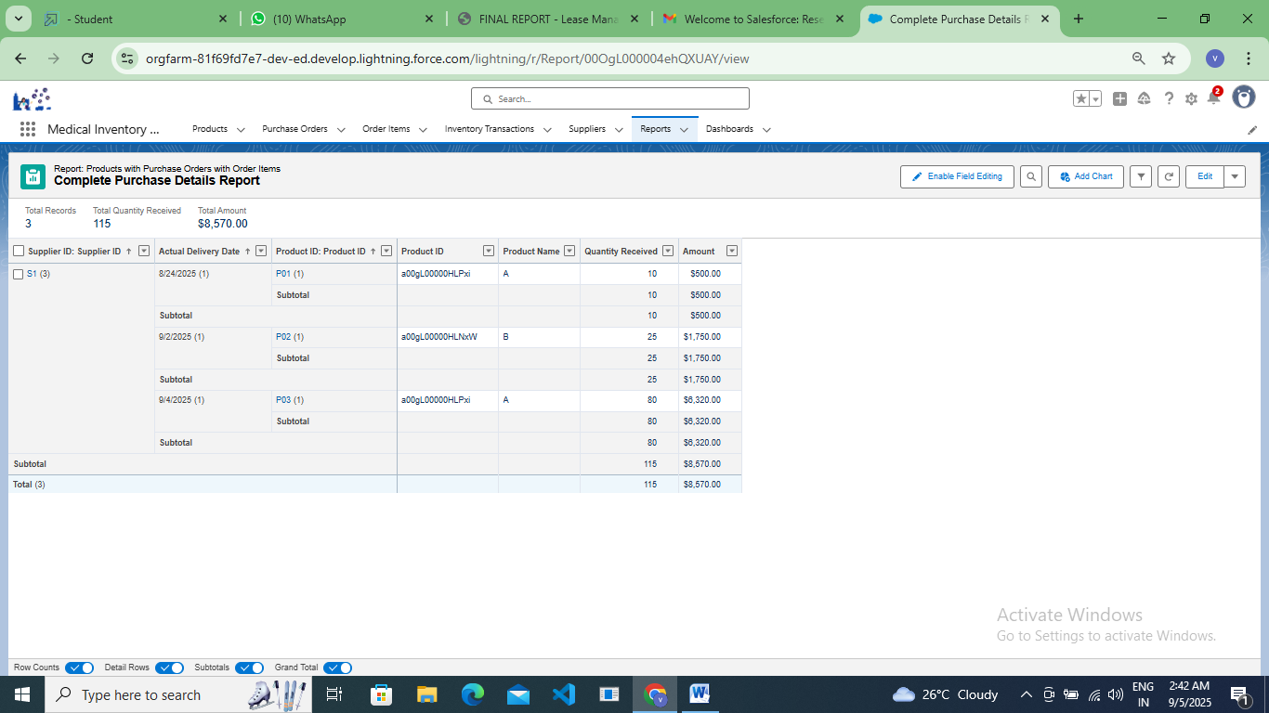

### Dashboards

### Create Dashboard

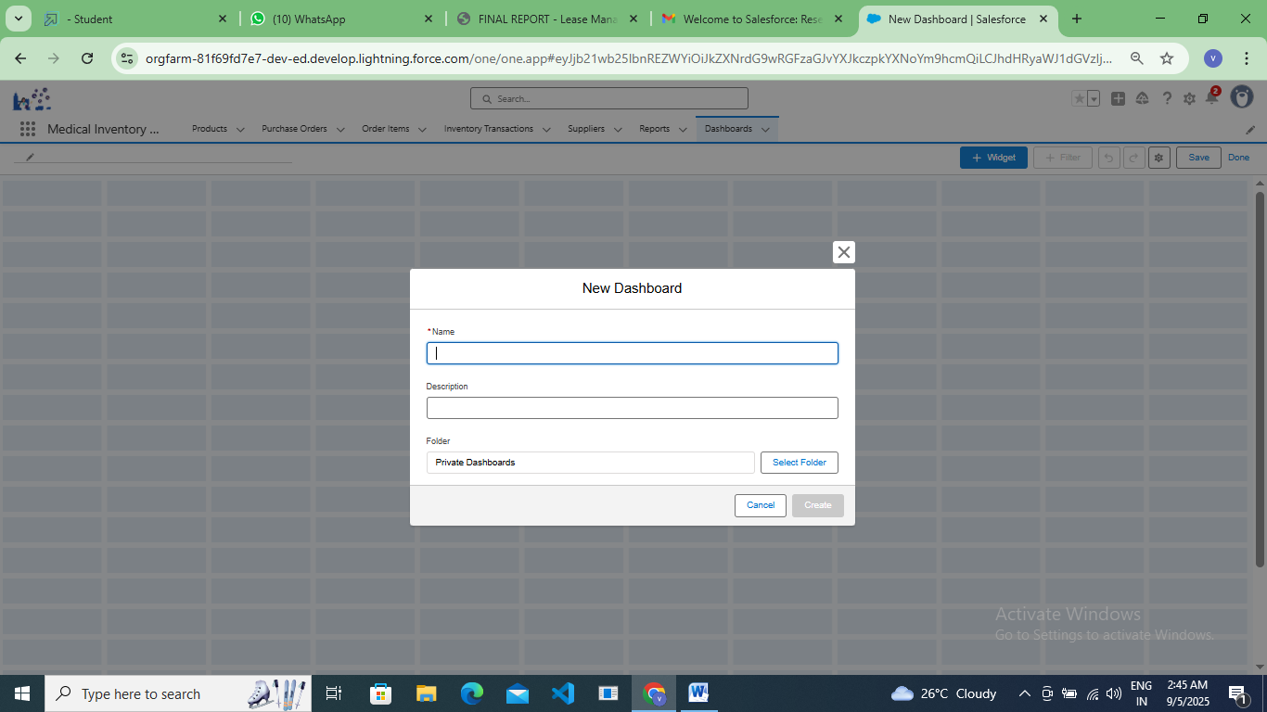

### View Dashboard

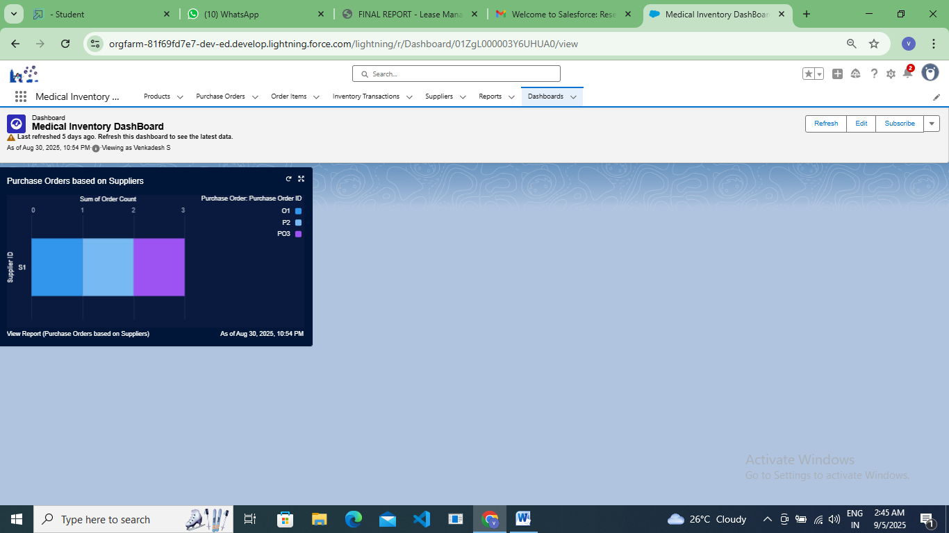

**FUNCTIONAL AND PERFORMANCE TESTING**

**Performance Testing**

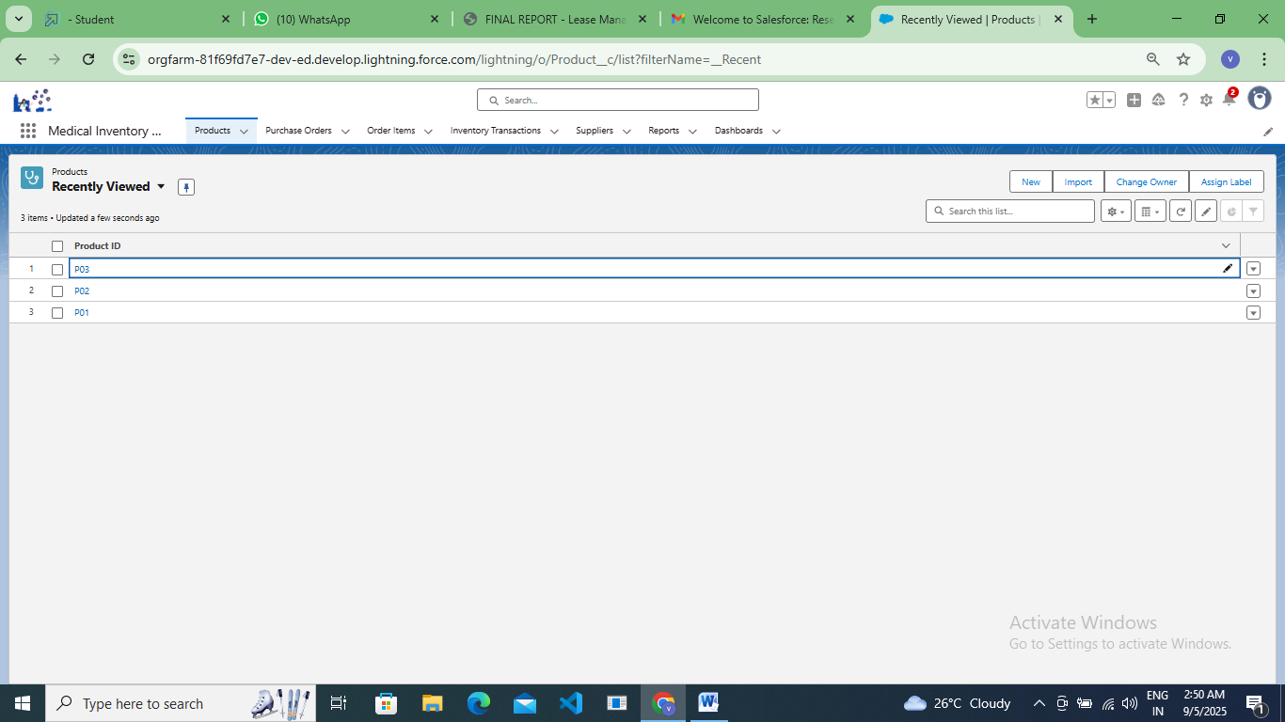

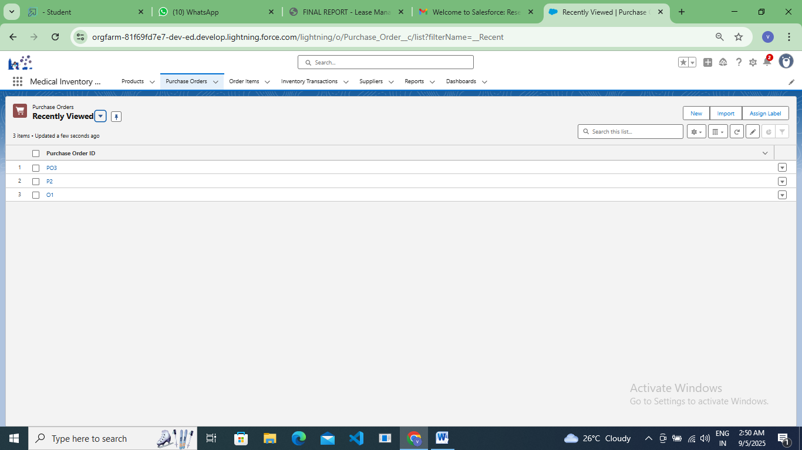

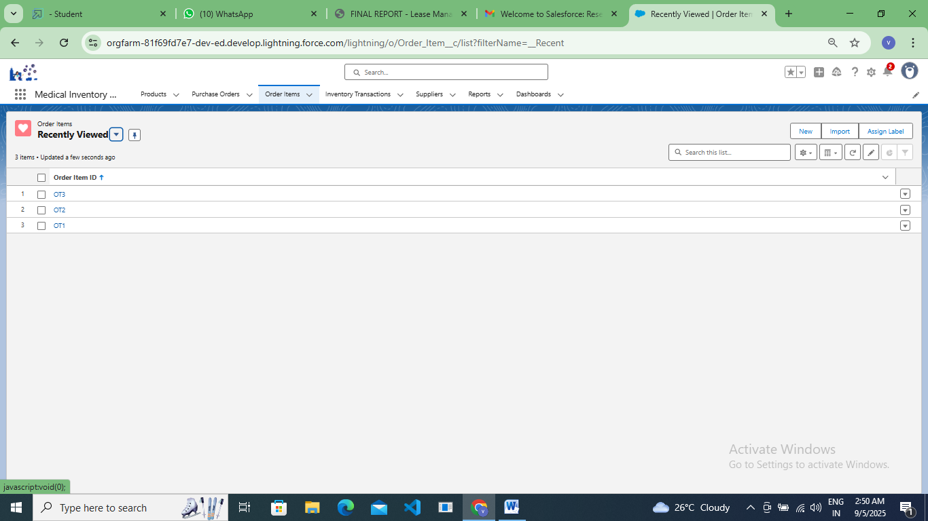

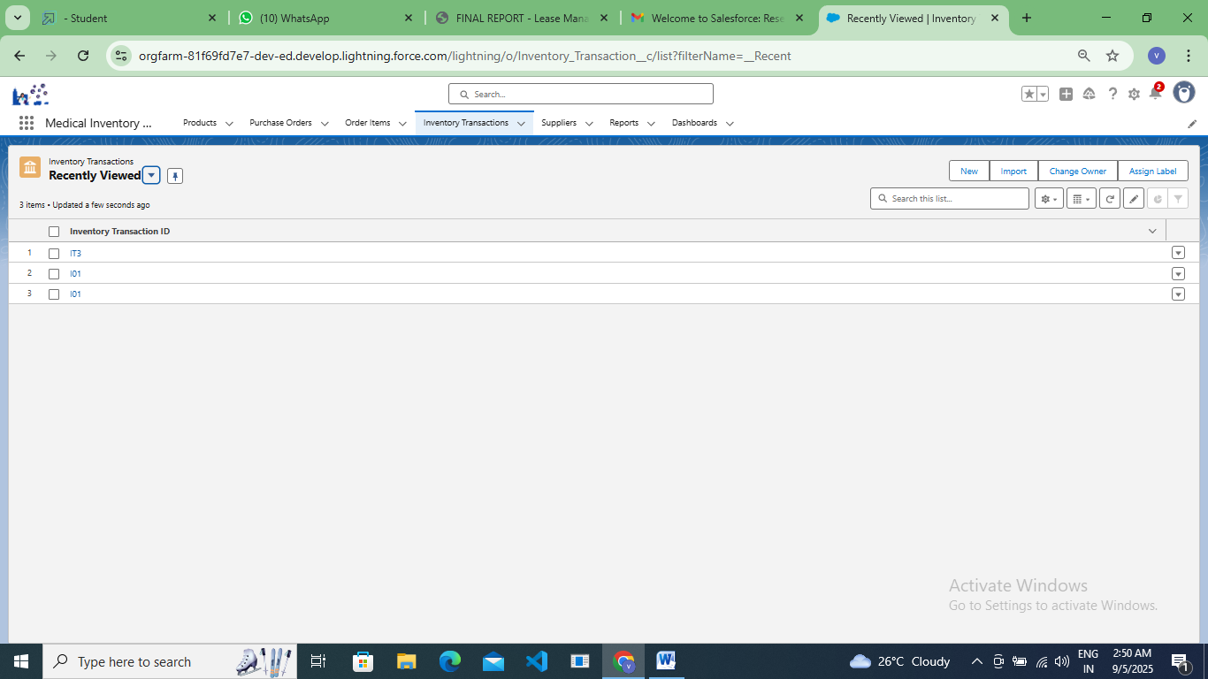

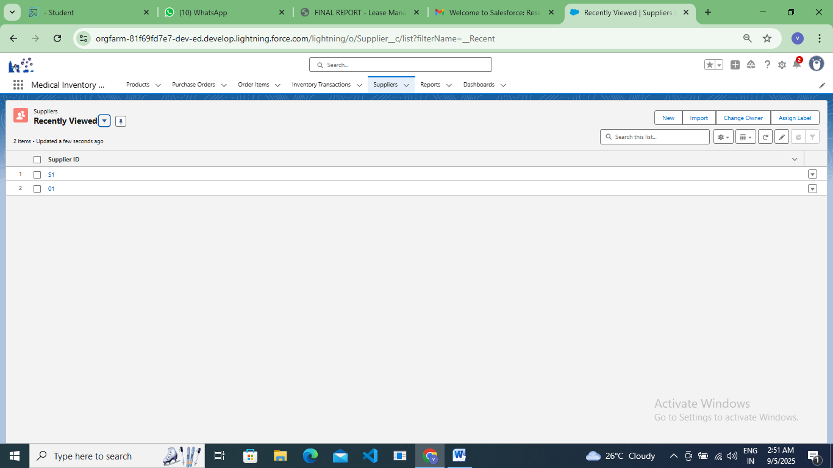

**-------------------------------------------------------------------------------------------------------------------------**

**RESULTS**

**Output Screenshots**

### Objects

### To check added objects reflect in medical inventory management page

### 

### Tabs

### To check objects tabs added in custom object tabs

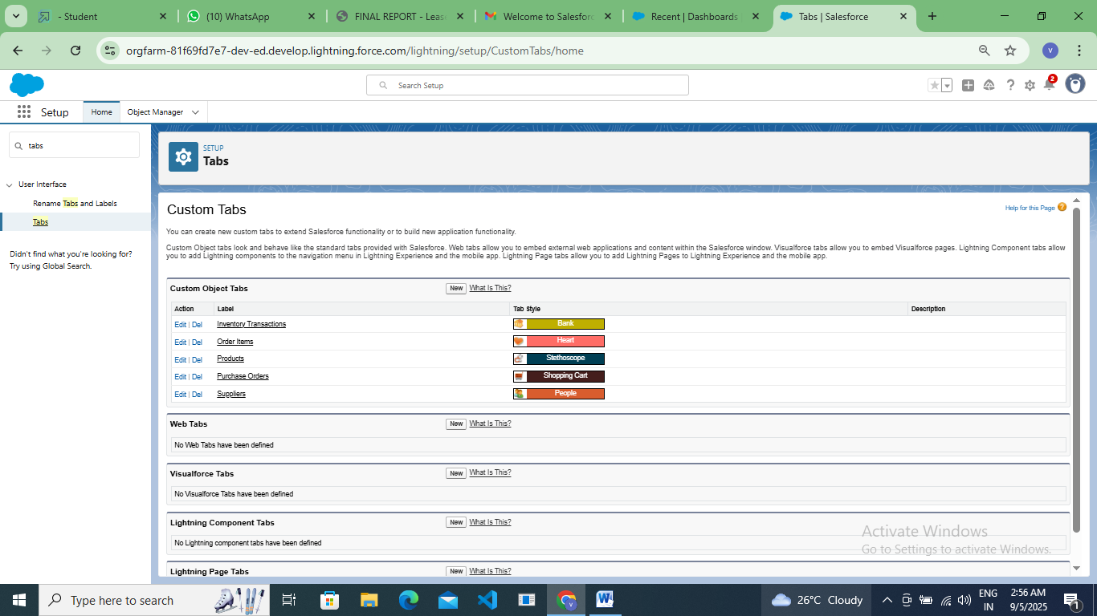

**Add the stock details in Medical inventory management in app launcher**

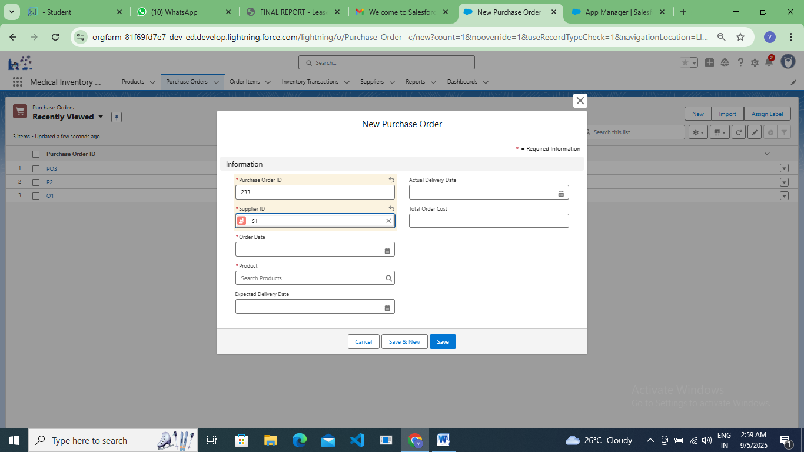

**Create the reports and view the reports in medical inventory management page**

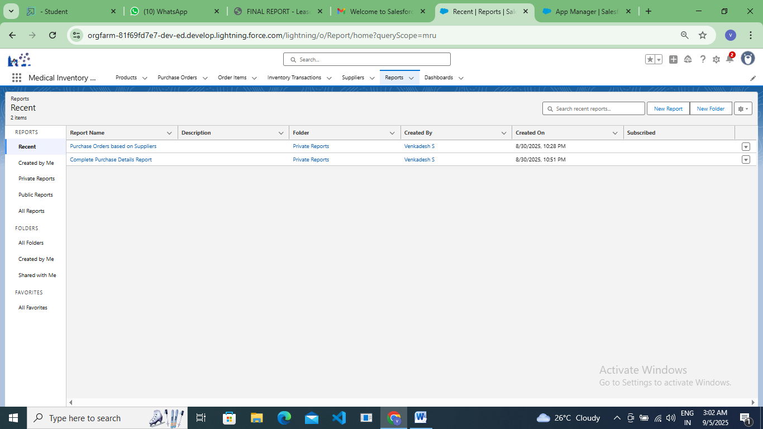

**View the created dashboard in medical inventory management page**

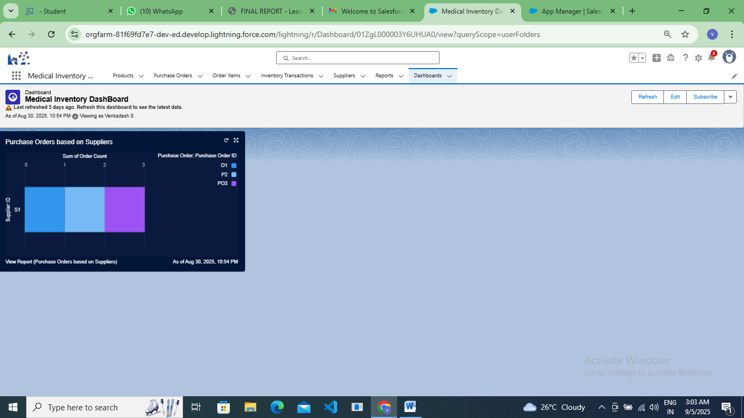

**CONCLUSION**

The Medical Inventory Management System successfully streamlines the operations of medical inventory through a structured, automated Salesforce application. It improves efficiency, communication, and data accuracy for both admins and users.